“**A Sound of Thunder”**

**by Ray Bradbury**

1. If you could go back to any point in history, when would it be? Explain your interest in your selection.
2. Why is suspense an engaging and exciting genre for many readers? How does Bradbury manage to keep the reader in suspense?



1. a) Define satire.

b) Why does science fiction work so well for satire? (ex. [Jurassic Park](https://www.youtube.com/watch?v=4PLvdmifDSk))

c) Why might we consider the following areas as fertile grounds for satire today:

cloning,

space travel, or

genetic engineering

1. Bradbury relates to our senses to create effective imagery. Locate two examples for each of our senses: sight, sound, smell, touch, taste.
2. Is “A Sound of Thunder” more interpretive or escapist? Explain your choice.

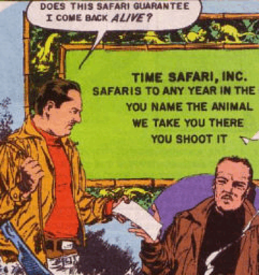

1. Creative Extension (see rubric on my website):
2. Create an 8-frame storyboard or a comic strip based on a scene from “A Sound of Thunder”.

1. Write an extended ending which further describes and develops the world after Eckels returns from his trip.
2. Prepare an informational brochure that Time Safari, Inc might have produced.

d) Create a video advertisement for Time Safari, Inc that promotes their company and the kinds of tours one can take.